(Template for Misasa2017 & Core-Mantle Coevolution symposium. Remove this before upload.)
Low-frequency micro-Raman spectroscopy and its application to mineral sciences
M Kanzaki^{1*} ¹Institute for Planetary Materials, Okayama University, Misasa, Tottori 682-0193, Japan.
*email:mkanzaki@okayama-u.ac.jp

Introduction: Because of advent of simple and cheap Raman system with single monochromator plus CCD detector, low-frequency Raman (below ~200 cm⁻¹) becomes nearly obsolete in last two decades. This is due to lower frequency limit of Raman filters (+ dichroic filter) used for those spectrometers. However, this situation has changed in last few years, as Ondax Inc. introduced new Raman filter which allows measurement down to ~5 cm⁻¹. Simultaneously, terahertz spectroscopy (corresponding far-infrared region) is now available to non-specialists. Therefore, new era of terahertz-region spectroscopy has arrived.
Although low-frequency region is not quite necessary for phase identification of materials (one of most used applications), it contains rich information of dynamics and local structure of materials. Boson peak in glasses and soft mode of phase transition are a few well known examples. In the talk, a few examples of applications to minerals are given to demonstrate ability of low-frequency Raman spectroscopy.
Experimental: For micro-Raman measurement, a home-build spectrometer with single-monochromator and CCD detector was used. Two Ondax SureBlock filters are adopted to the system to obtain low-frequency Raman spectra. We also employed a Ondax NoiseBlock filter, which works as a dichroic mirror. 488 nm solid laser with laser power of 80 mW was used. See [1] for details of the instrument.
For high-temperature measurements, a wire-heater was used, and temperature was calibrated against 5~6 standard materials with known melting points [2].
Results and Discussion: First example is soft mode of α-AlPO₄-moganite. This is a high-pressure phase synthesized at 5 GPa, 1500 ˚C [3]. Similar to SiO₂-moganite and other silica phases such as quartz, temperature-induced phase transition is expected. This supposed transition was studied using present micro-Raman system up to 600 ˚C. Two low-frequency modes (60 and 74 cm⁻¹) were detected at room temperature. The 74 cm⁻¹-mode significantly shifted toward 0 cm⁻¹ with temperature as shown in Fig. 1. This behavior is well fitted with an order parameter equation as shown in Fig. 1, confirming that the mode is soft mode. The transition temperature (T_{c}) was determined as 415 ˚C. First-principles calculation of vibrational modes of α-AlPO₄-moganite predicted two low-frequency modes, and atomic displacements for the 74 cm⁻¹-mode matched well toward to route for the expected high-temperature structure.
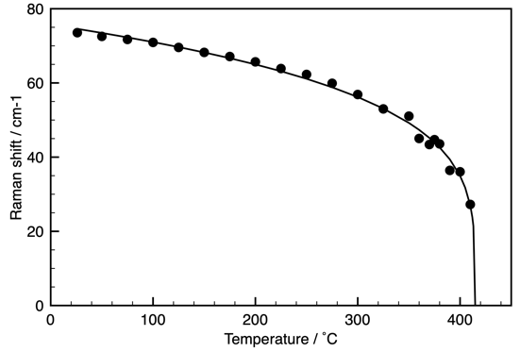
Figure 1 Soft mode Raman shift of α-AlPO₄-moganite versus temperature (sold circles). The solid line represents curve fitting using an order parameter equation (ω_{s} = A|T_{c}-T|^{β}).
Second example is low-frequency peak observed in natural minerals. We found a very intense (and broad) low-frequency Raman peak in a CO₂-containing melanophlogite as shown in Fig. 2 [4]. Melanophlogite is one of rare silica minerals with a clathrate structure. Heating study of this sample revealed that this feature is due to CO₂ in the structure and is likely due to librational and translational modes of CO₂ molecules in cages, as degassing reduced its intensity. Degassing behavior which is related to diffusion of CO₂ in cages of the structure, can be studied by observing this and also CO₂ vibrational peaks [4]. Low-frequency peaks are also found in several zeolites which are likely originated from molecular H₂O clusters in the large cages of zeolites.

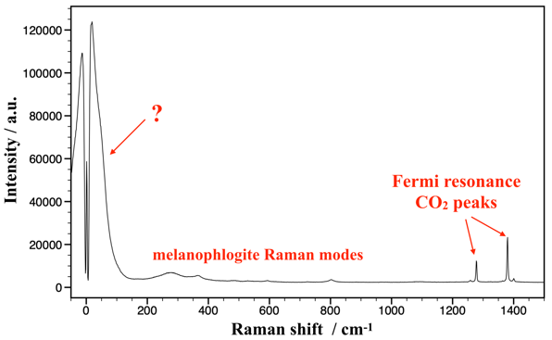
Figure 2 Raman spectrum of CO₂-containing melanophlogite from Fortunillo, Italy at ambient conditions.
References: [1] http://www.misasa.okayama-u.ac.jp/pukiwiki/index.php?Micro-Raman spectroscopy [2] Kanzaki, M., J. Mineral. Petrol. Sci., 113, 126 (2018). [3] Kanzaki, M. and Xue, X. Inorg. Chem., 51, 6164 (2012). [4] Kanzaki, M., J. Mineral. Petrol. Sci., 114 (2019) in press.

